

**Managing stockouts in a health care manufacturing factory**

Name - Utkarsh Balooni

Roll No. - 22ds1000021

**1. Executive Summary:**

The objective of this project is to devise feasible strategies to minimize stockouts and optimize inventory levels for a factory manufacturing pharmaceutical products. The mid-term report outlines our progress and accomplishments in the project thus far.

The report contains an official letter from Ved Lifesavers Ltd. and several images as a proof of originality of the data. The data collected for the analysis pertains to raw (packing) materials receiving against purchase order for the years 2021-2023. Data for all the years is consolidated and basic pre-processing techniques are carried out on the data. Metadata and basic descriptive statistics for the dataset is presented. After this, a combination of ABC-VED analysis is performed on the data and the products with the highest profitability are shortlisted. Average monthly demand for these products is computed and the demand is forecasted using ARIMA model. Order lead time and standard deviation of demand for the products is also calculated for further use.

Finally, safety stock and reorder point for the products is calculated using appropriate formulae. All analysis done is accompanied by relevant visual representations.

We will be analysing only 1 raw material for the mid term report. The same analysis will be extended in the final submission.

**2. Proof of originality of the data:**

Link to the drive containing letter from the organization and data - <https://drive.google.com/drive/folders/1JmXokpoq8JN_xKnqoDxGK4T6oQp66SVg?usp=share_link>

**3. Metadata and Descriptive Statistics:**

Snapshot of the raw dataset:

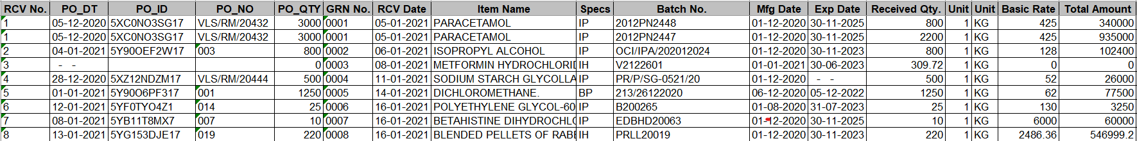

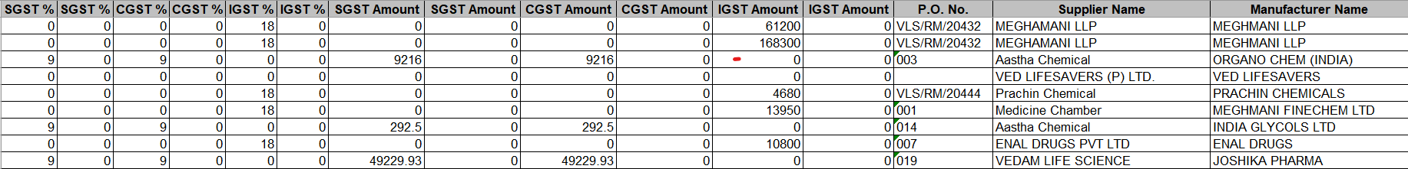

The relevant variables in the dataset are as follows:

|  |  |  |
| --- | --- | --- |
| Variable Name | Variable Description | Variable Relevance |
| RCV No. | Index Number | General Purpose |
| PO_DT | Date of procuring the purchase order. | Used in lead time calculation and demand forecasting. |
| PO_QTY | Quantity of goods required in the purchase order. | Used in ABC-VED analysis. |
| RCV_Date | Date of receiving the raw materials. | Used in lead time calculation. |
| Item Name | Name of the raw material. | General Purpose |
| Received Qty. | Quantity of raw materials received. | Used in demand forecasting. |
| Unit | No. of units | Used for calculating total received qty. |
| Basic Rate | Unit price of raw material. | Used for calculating total received qty. |
| Total Amount | Total price of the raw materials purchased. | Used for ABC-VED analysis. |

**Data Cleaning:**

Step-1: Only the relevant columns from the dataset are selected.

Step-2: Total rcv qty is calculated as Received Qty. × Unit.

Step-3: Shelf life for the products is calculated as the no. of days between Mfg_Date and Exp_Date.

Step-4: Remove any missing values from the dataset. A total of 7 rows were removed.

Step-5: Check for any inconsistent entries in the dataset. None were found.

Snapshot of the cleaned dataset:

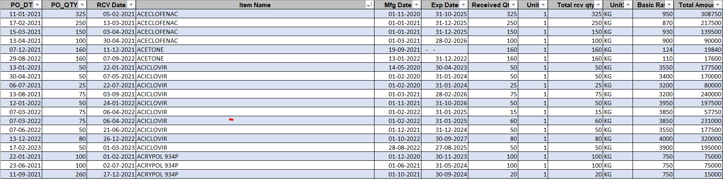

**Descriptive statistics for the dataset:**

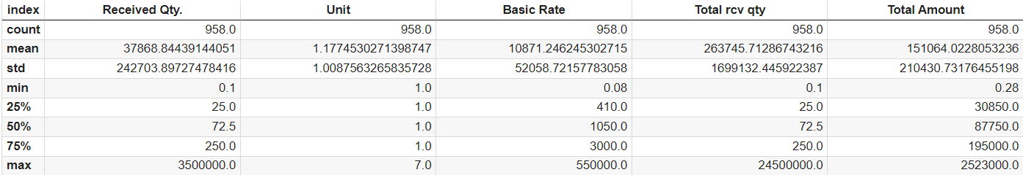

* There are a total of 154 unique raw materials (item names) in the dataset.
* Earliest date in the dataset: 26-10-2020
* Latest date in the dataset: 21-03-2023
* Total number of days for which the data is collected: 876 days

Histogram for Total amount and Total received quantity column is shown below:

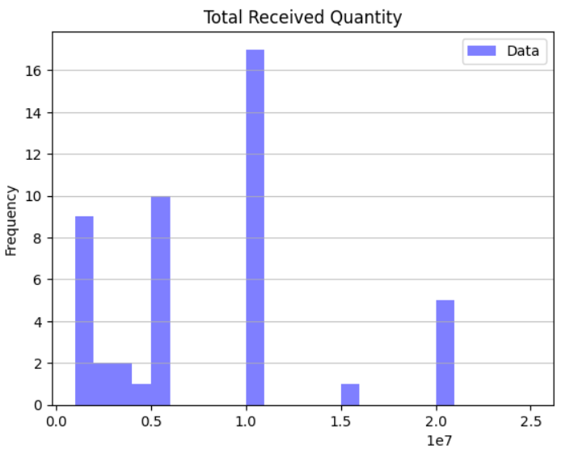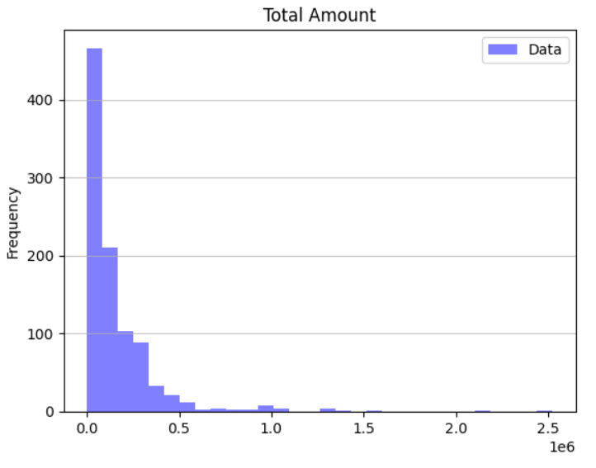

Pareto chart for the data using total amount as value is shown below:

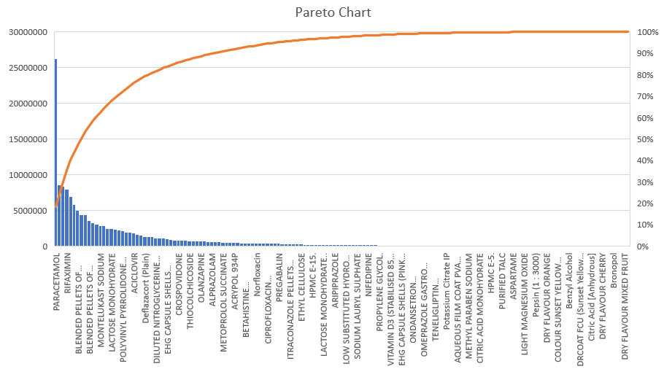

It is clear from the chart that the data follows the pareto principle.

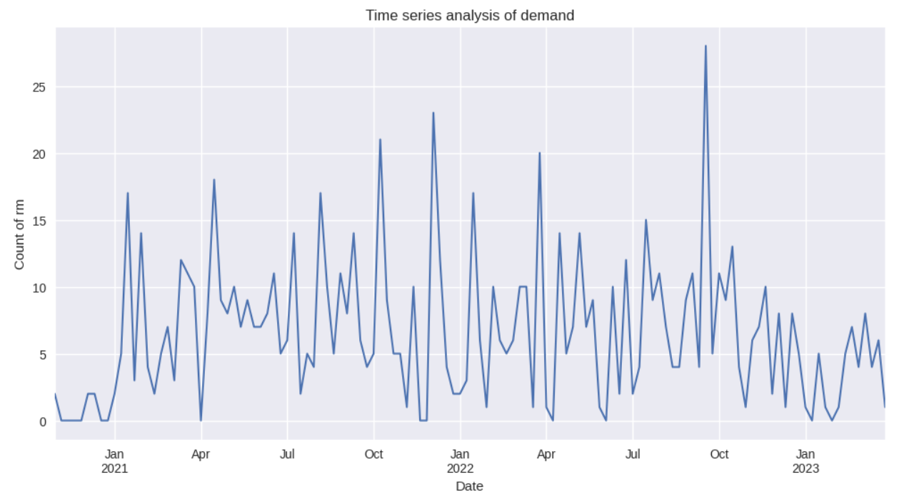

The plot shows the number (count) of raw materials required for the purchase orders weekly. On an average 6.595 number of raw materials were used each week.

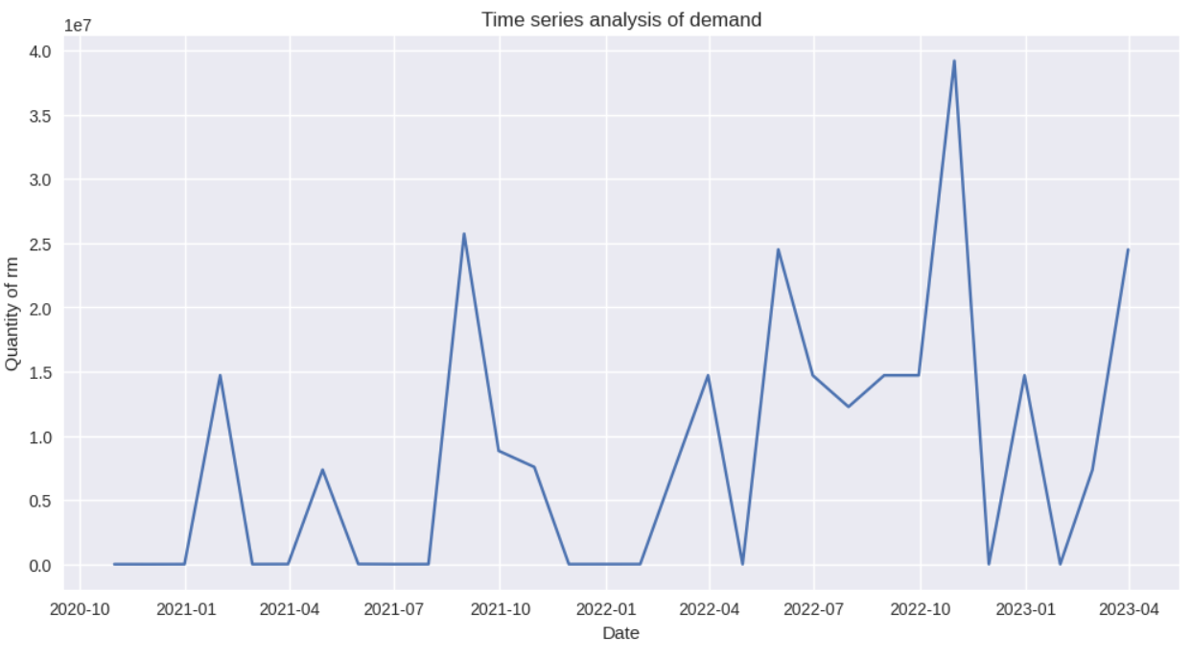

The plot shows the quantity of raw materials required for the manufacturing process by date (monthly).

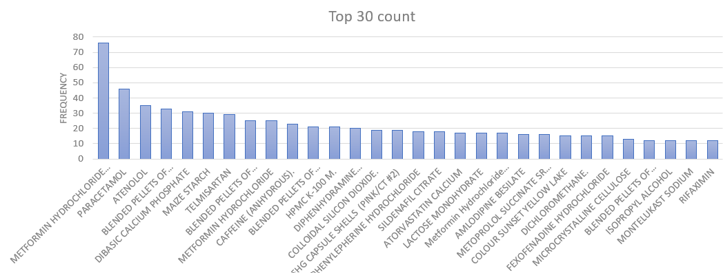

The bar chart displays the frequency of the top 30 item names included in the dataset.

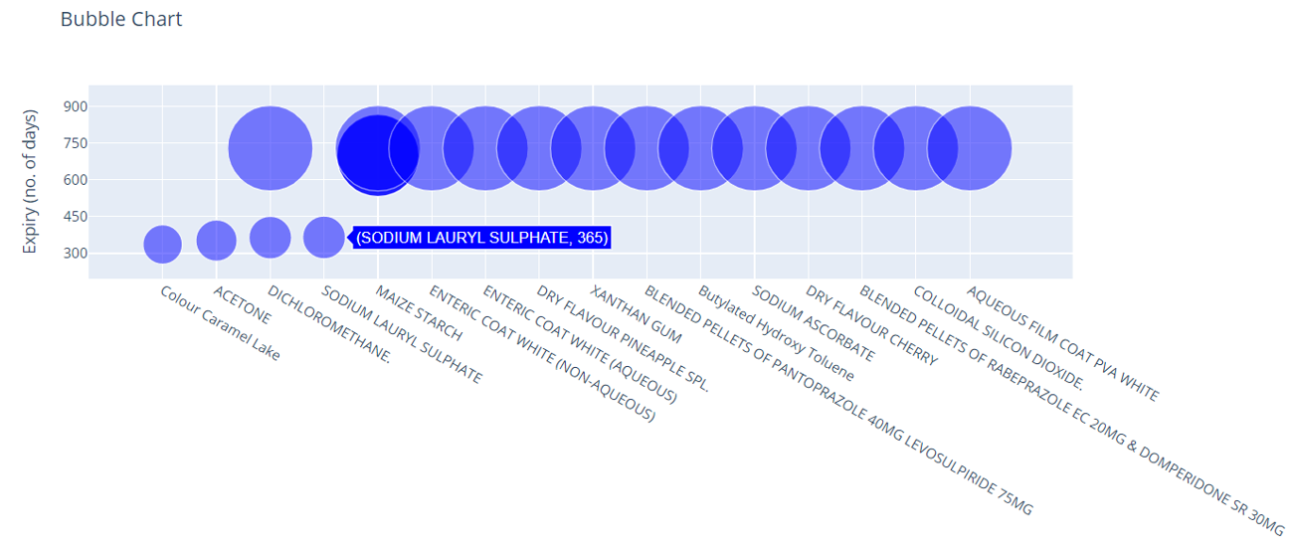

The bubble chart shows the shelf-life duration for 20 products in the dataset with the shortest lifespan. “Colour Caramel Lake” has the minimum shelf life equal to 336 days ≈ 1 year.

**4. Detailed explanation of analysis:**

**ABC-VED analysis:** This is performed for shortlisting the most profitable raw materials.

ABC analysis is performed on the dataset using the total amount column as value. The items are aggregated and the sum of total amount for all items is calculated using a pivot table in MS Excel. Next, percentage contribution of each item in the sum of total amount is calculated, followed by cumulative percentage calculation. Finally, the items are categorized as “A”, “B” or “C” based on the following logic:

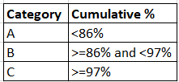

VED analysis is performed on the dataset using the issue frequency as value. The items are aggregated and the count of item name for all items is calculated using a pivot table in MS Excel. Next, percentage contribution of each item in the issue frequency is calculated, followed by cumulative percentage calculation. Finally, the items are categorized as “V”, “E” or “D” based on the following logic:

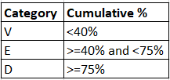

While ABC analysis focuses on the total cost of raw materials issued, VED analysis focuses on the frequency of issuance of these raw materials. Combining ABC-VED analysis we shortlist the products that have the highest total issue amount as well as the highest frequency of usage, thereby having highest profitability.

Result for the ABC-VED analysis is shown in the table below:

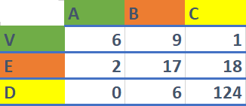

We will only be focussing on items that belong to the “V-A” category.

**Lead time calculation:** Lead time for the shortlisted products is calculated in the excel sheet as RCV_Date – PO_Date.

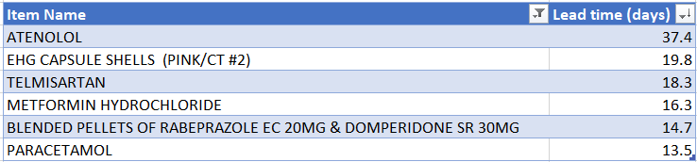

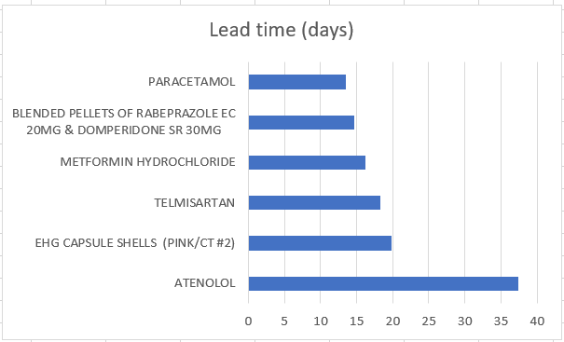

**Demand Forecasting:** Demand forecasting is done using ARIMA (auto regressive integrated moving average) model in python. The data (for atenolol) is first converted into a format suitable for forecasting.

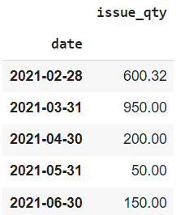

After this, ADF test is applied on the data to check if it is stationary.



Then, the parameters of the model are estimated using autocorrelation plots and partial autocorrelation plots.

Finally, the model is fitted on the data.

**Safety stock and Reorder point calculation:** First we calculate the average monthly demand and standard deviation of demand during lead time for the product “Atenolol” using python. We will be converting all time related variables to unit of months.



The formula used for safety stock calculation is:

Safety Stock

where,

Z – number of standard deviations required to achieve the desired service level. Can be found in a Standard Normal distribution table.

– Standard Deviation of demand during lead time.

L – Lead time in appropriate units.

We calculate safety stock for a desired service level of 90%. Using a standard normal distribution table, it can be obtained that Z = 1.28 for a 90% service level.

Using these values, we get the value of safety stock as **396 units**.

Formula used for reorder point calculation is:

Reorder Point = (Average monthly demand × Lead time) + Safety stock

Reorder point for atenolol is **702 units**.

**5. Results and Findings:**

* The most profitable raw materials of the factory were shortlisted.

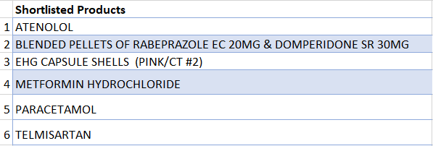

* Demand was forecasted for the product “Atenolol”.

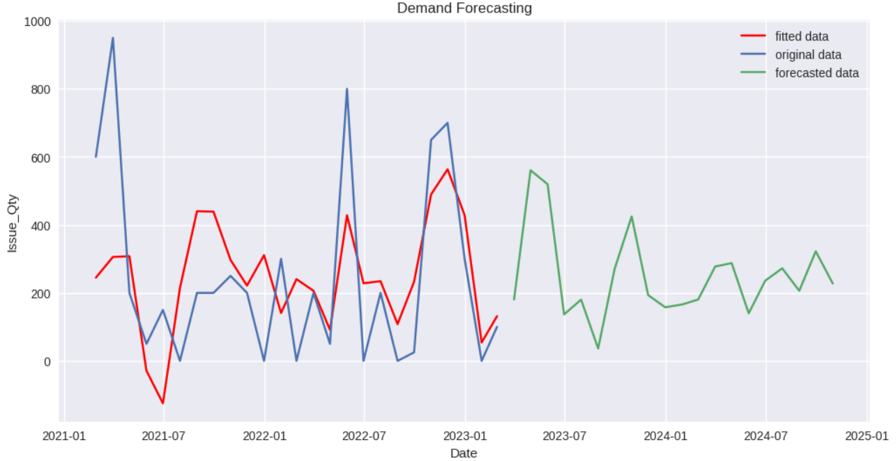

* Safety stock and reorder point for “Atenolol” were calculated as 396 units and 702 units respectively. 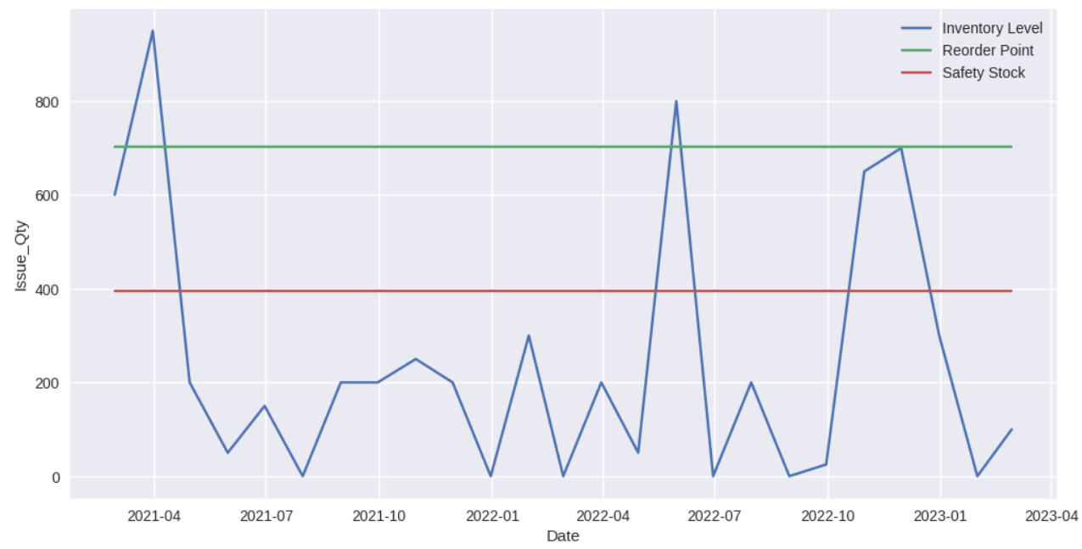
* Due to high variability in the demand data the value of safety stock and reorder point is quite high.
* We will intelligently find and remove outliers in the data for the next analysis to prevent this.